Triathlon racing round up
On Saturday 21st August, a troop of 5 local triathletes took the trip along the South East Coast of Ireland to Fethard-On-Sea in the Model County of Wexford to represent Tried & Tested Triathlon Club at Tri The Hook Sprint Triathlon.
The forecast was pretty grim going into Saturday and certainly was accurate early on with a very damp start to the day but miracles can happen and, lo and behold, the clouds parted and the sun began to shine against all odds and predictions just as the race was ending to greet the athletes at the finishing line.
As has become the norm these days for Triathlon post-COVID, the start was divided into Waves, each with it’s own rolling start, Niall Barry and John O’Rourke who made up the male contingent on the day both got off early in Wave 1 while the ladies (made up of Nic Moroney, Kate Mitchell, Tasha Lanigan, Aisling Horgan and daughter, Caoimhe had to wait a little longer to start in the later Waves.
The swim was choppy and the cycle was wet and technical with riders coming against each other at times. Along with poor road surfaces in places, this made for a challenging bike section so triathletes were already battle weary before the final run section started. Thankfully, the run was slightly shorter than the regulation 5k which ended the suffering slightly earlier than most were expecting.
John O’Rourke went one better than his result in Kilkenny in July to secure the third step of the podium behind rivals, Paul Ogle and Enda Bagnall. John posted the exact same times as Enda for the bike and run and it was only a slightly slower swim that made the difference. John has been struggling with an injury in his hip which he is close to shaking off so is only going to get faster as the season progresses. Watch this space!
Seasoned and solid performer, Niall Barry was next Tried & Tested triathlete home in a top flight position of 30th out of the 315 starters on the day.
Arguably Tried & Tested’s fastest female at the moment, Nicola Moroney, was first home of the ladies in an impressive 61st (11th female in a field that contained some of Irelands top female talent at the moment). Then came rising star, 17 year old Caoimhe Horgan, who has shown a lot of promise in training and recently won her first Club Aquathlon on Clonea beach in July. Caoimhe posted a very impressive top half result for her debut outing. Another great result was Kate Mitchell who was also making her triathlon debut and smashed it, managing to keep 171 athletes behind her at the finishing line. And finally, the bubbly and ever-popular duo of Aisling Horgan and Tasha Lanigan rounded off the Tried & Tested contingent to cross the finishing line together in jubilant form.
While the club celebrated our success in Wexford on Saturday, Niall Connaughton quietly headed off to Denmark to compete in Ironman Copenhagen on the Sunday where he posted a phenomenal 10hrs 44min for the 3.8km swim, 180km bike and full marathon (42.4km) which puts him in a very exclusive sub 11 hour club for the full Ironman. Niall completed the swim in 1hr 11 min, the bike in 5 hrs 25 min and the run in 3hrs 58 min. I think it is safe to say that Niall Connaughton is an Ironman!
Another great weekend for Tried & Tested Triathlon Club!
Tri The Hook Final results
1st Paul Ogle Waterford Triathlon Club
2nd Enda Bagnall Edenderry Triathlon Club
3rd John O’Rourke Tried & Tested, Dungarvan
Other Tried & Tested results:
30th Niall Barry
61st Nicola Moroney
114th Caoimhe Horgan
143rd Kate Mitchell
232nd Aisling Horgan
236th Natasha Lanigan
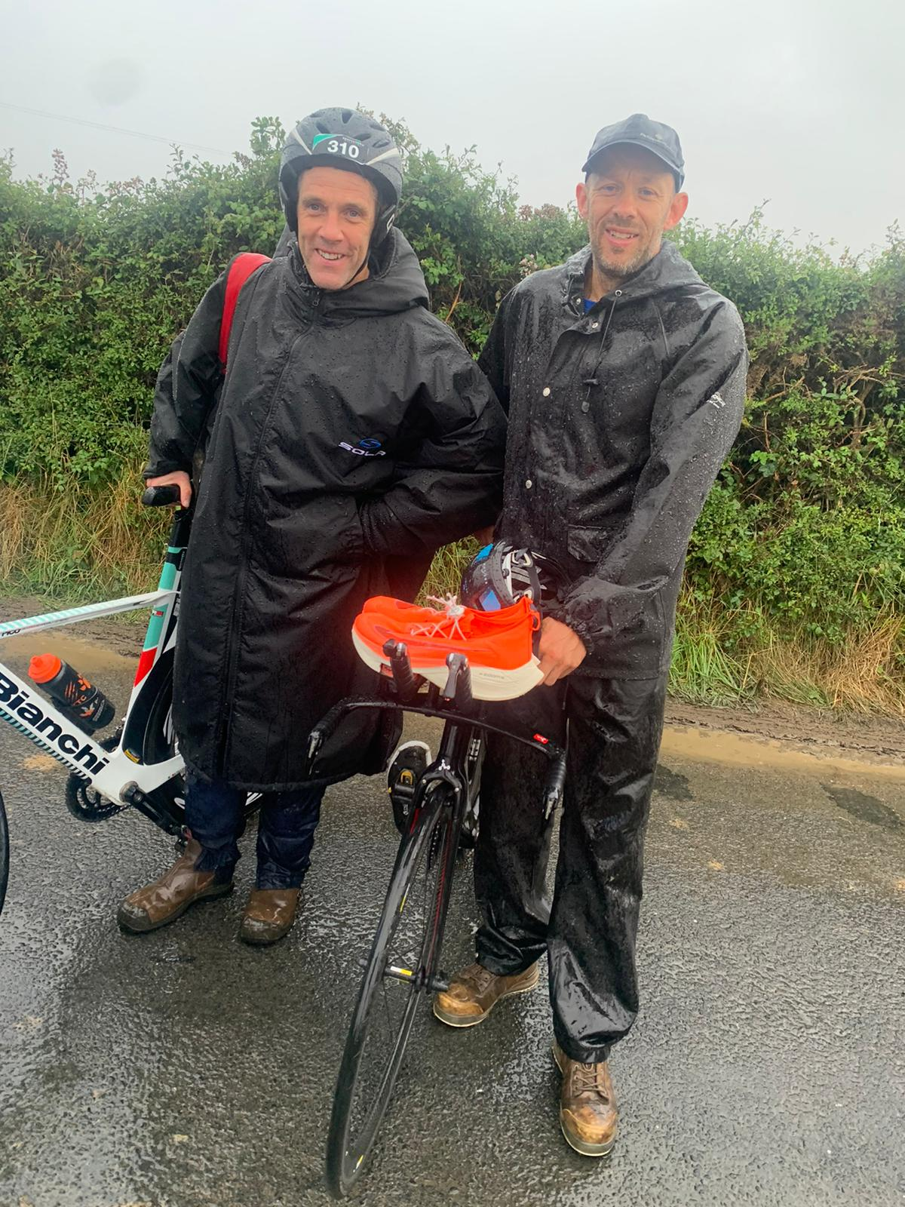
Niall Barry (L) and John O’Rourke getting acclimatised early for the swim!
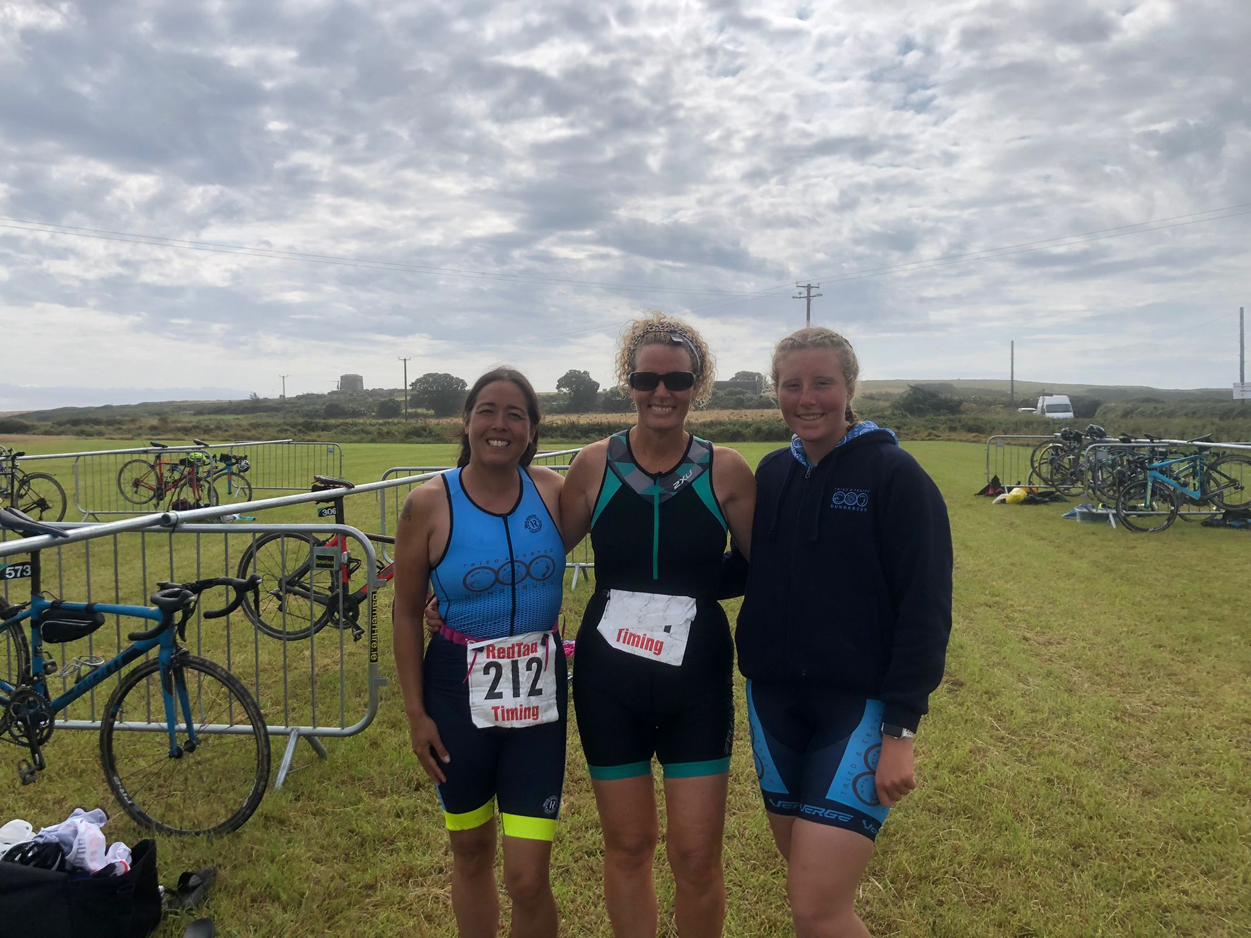
(L to R) Tasha Lanigan, Aisling Horgan and Caoimhe Horgan who made up the ladies contingent of the Tried & Tested team on the day
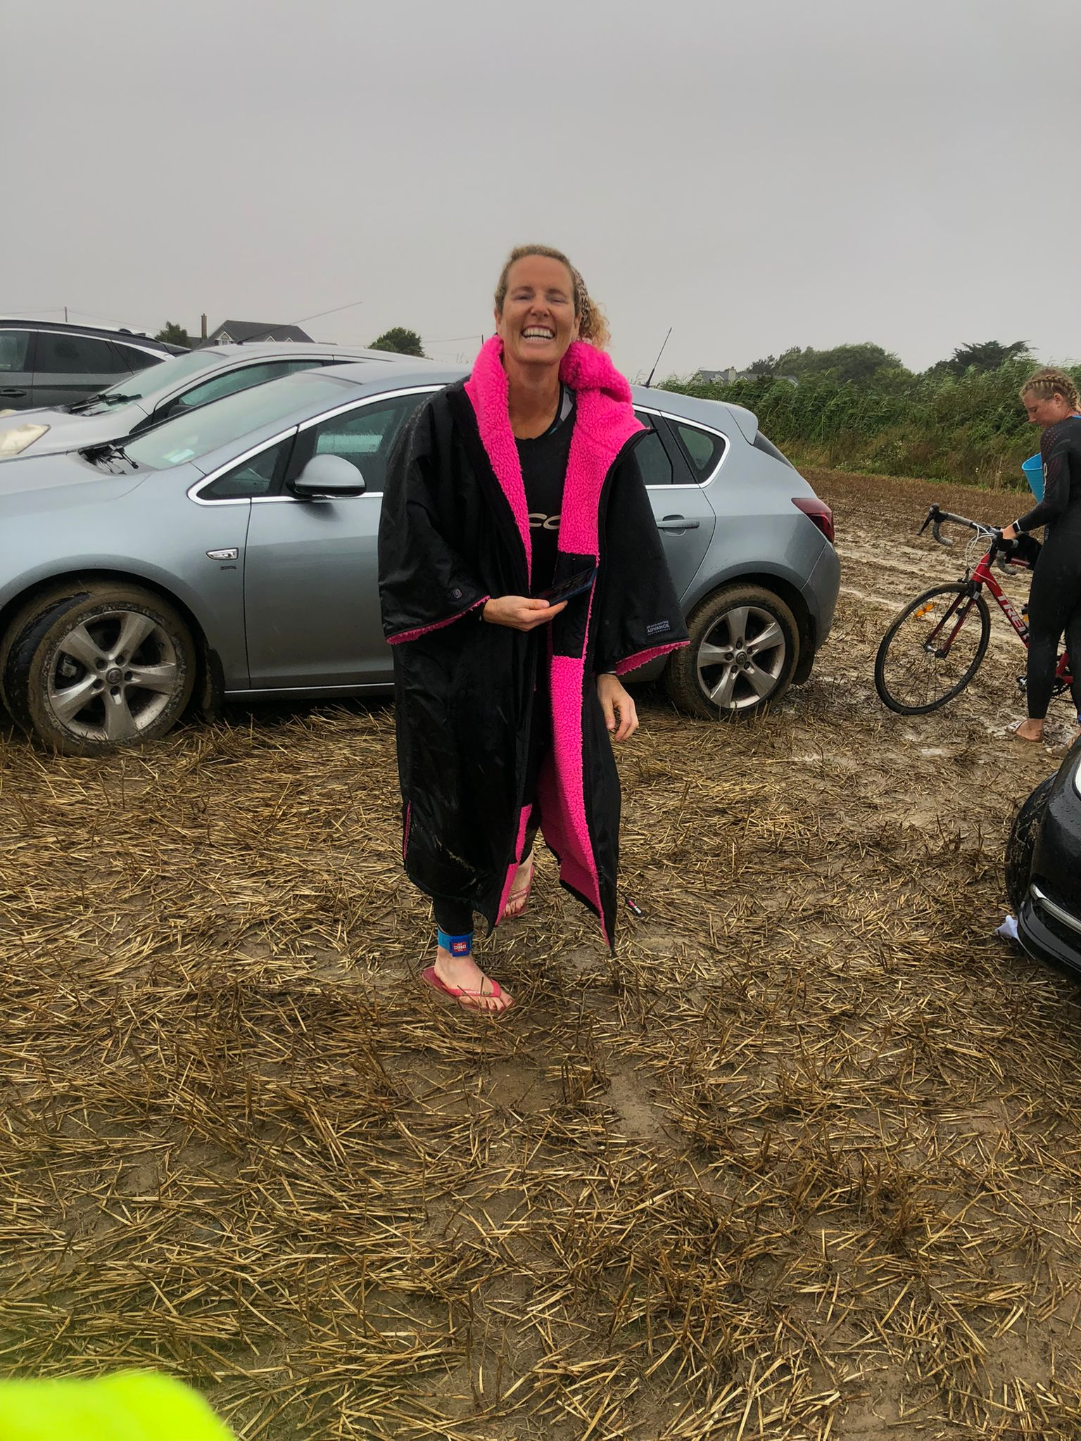
Stuck in the mud! Luckily, it was Aisling Horgans car that got stuck and not her bike in the middle of the race course!
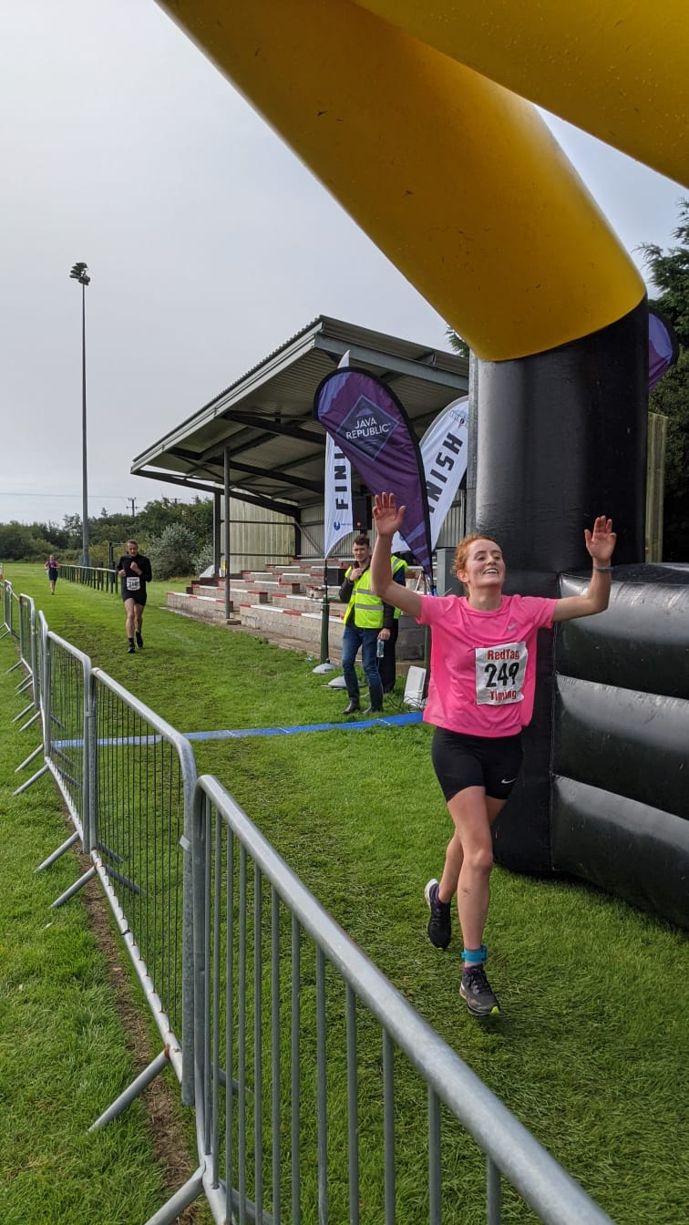

Kate Mitchell can’t believe she made it to the finish line in her first ever triathlon
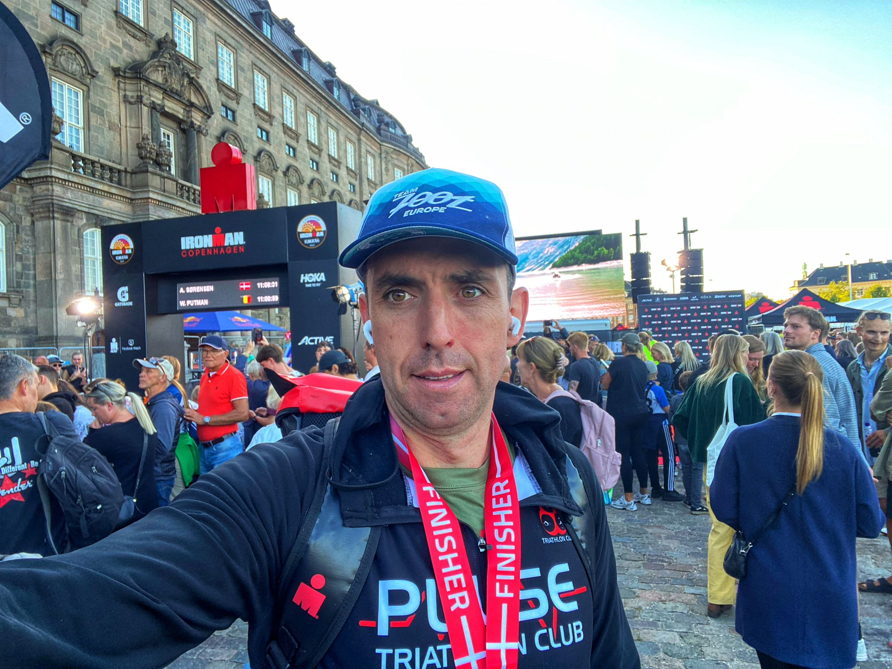
Still standing! Niall Connaughton at the end of an epic day in Copenhagen.

